Supplemental Information
Cellular Communication Network Factor 3 contributes to the pathological process of rheumatoid arthritis through promoting cell senescence and osteoclastogenesis in the joint
Tokuhiro et al. 2024

*Corresponding Author: M Alaa Terkawi, DVM, PhD, Department of Orthopaedic Surgery, Faculty of Medicine and Graduate School of Medicine, Hokkaido University, Kita-15, Nishi-7, Kita-ku, Sapporo, Japan.
Telephone: +81-11-706-5935, Fax: +81-11-706-6054.
E-mail: materkawi@med.hokudai.ac.jp

Supplementary Figure 1. Gene expression of SASP in stimulated FLS as determined by qRT‒PCR. Results represent the means of relative expression values ± SEM (n = 3). Significant difference between the groups was determined by one-way ANOVA, followed by Tukey's multiple-comparison procedure. * p < 0.05, ** p < 0.001, *** p < 0.0001, **** p< 0.00001. ns, not significant.

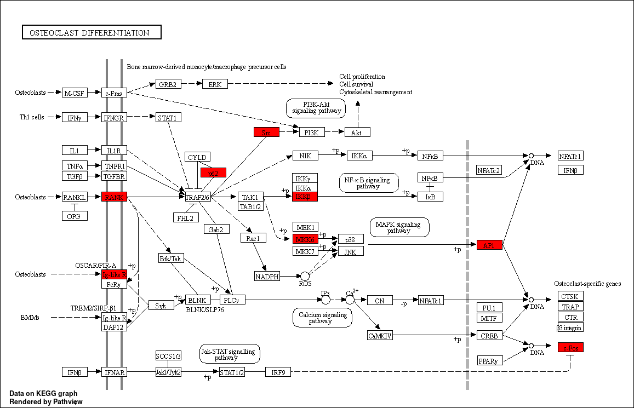
Supplementary Figure 2. Differentially expressed genes in the stimulated monocytes with CCN3 are enriched in the KEGG osteoclast differentiation pathway.

Supplementary Figure 3. Gene expression of SASP in calvarial bone after administration of CCN3. Results represent the means of relative expression values of the qRT‒PCR ± SEM from 4 mice (n = 4 ± SEM). Significant difference between the groups was determined by two-tailed Student’s t test.. * p < 0.05, ** p < 0.001, *** p < 0.0001, **** p< 0.00001. ns, not significant.

Supplementary Table 1. Primer list used in this study.

Target | Forward | Reverse
GAPDH | GACAGTCAGCCGCATCTTCT | CCATGGTGTCTGAGCGATGT
RUNX 2 | TCTCCAGGAGGACAGCAAGA | GCAGCCTTAAATGACTCTGTTGG
Col 1 | ACTGGCGAAACCTGTATCCG | CCAGTTCTTGGCTGGGATGT
VEGFA | AAAACACAGACTCGCGTTGC | CCTCGGCTTGTCACATCTGC
SPP 1 | CTGAACGCGCCTTCTGATTG | GGGTTTCAGCACTCTGGTCA
IL-6 | AGAAAAAGGTGGGTGTGTCCT | GTCTTTGAGCCTGTCTTCCCC
IL-8 | TССАААССТТТСАССССААА | AATTTCTGTGTTGGCGCAGTG
TGF-β | TTGAGGGCTTTCGCCTTAGC | AGTGAACCCGTTGATGTCCA
OPG | CGTGTGCGAATGCAAGGAAG | GCTTGCACCACTCCAAATCC
IL-1α | ACGCCTGGTTTTCCAGTATCT | AGCAAGACTACTGGGTGTGC
IL-1β | GCAGAAGTACCTGAGCTCGC | AGTCATCCTCATTGCCACTGT
CCL 20 | CCAAGAGTTTGCTCCTGGCT | CTTGCTGCTTCTGATTCGCC
RANKL | ATCTGGCCAAGAGGAGCAAG | GGGAACCAGATGGGATGTCG
MMP 1 | AGGTCTCTGAGGGTCAAGCA | TTGICCCGATGATCTCCCCT
MMP 3 | TCCTACTGTTGCTGTGCGTG | CCCTTGCAGCTCCATCCAAT

Supplementary Table 2. Antibodies list used in this study.

Antibody | Dilution | Manufacturer | Research Resource Identifier  (RRID)
GAPDH | 1:2000 | BioLegend | AB_2734502
phospho-p21 | 1:2000 | Bioss | AB_11097560
phospho-p53 | 1:2000 | GeneTex | AB_2886801
β-galactosidase | 1:2000 | Invitrogen | AB_2851905

