Supplementary Table S1. Primer sequences used in this study.
Primer name | Primer sequence (5’-3’) | Use of amplicon
GmBAS1_qRT_Fw1 | AGGGATGTGGAGGCTGAAGA | qRT-PCR
GmBAS1_qRT_Rv1 | TCTGCCTCCCCAACGAAATTGT | qRT-PCR
GmBAS2_qRT_Fw1 | AAGCGAAGGAGAGGATGTGGA | qRT-PCR
GmBAS2_qRT_Rv1 | GTTTGTGCTGAATATGTATGCCTC | qRT-PCR
Bic-C2_Fw | GCTATCAGGGACAATGGCAC | qRT-PCR
Bic-C2_Rv | CCATGACTTTTTAGGAGCTGGG | qRT-PCR
GmBAS1 Fw | GATCAGGGATGTGGAGGCTG | CAPS and sequencing analysis
GmBAS1 Rv | ACTCCTAAGCAAAACTGGAATCAA | CAPS and sequencing analysis
GmBAS2 Fw | GTGGAGGCTGAAGATAGCAGA | CAPS and sequencing analysis
GmBAS2 Rv | ATGTGTCGGGAAACAAGCAT | CAPS and sequencing analysis
off1_Fw1 | TAGCAGATGGTGGAAAAGACCC | Sequencing analysis of off-target
off1_Rv1 | TGGCCAATGGCTTGATGTCAC | Sequencing analysis of off-target
off2_Fw1 | GTGGAGGCTGAAGATAGCAGA | Sequencing analysis of off-target
off2_Rv1 | GGTTTGATGCAAGTATGTCACAA | Sequencing analysis of off-target
off3_Fw1 | CGAGGAATGGTGAACCTCGT | Sequencing analysis of off-target
off3_Rv1 | AGTAGGTCACCGCTTTGCTT | Sequencing analysis of off-target
off4_Fw1 | TACGTCGGAGAGTGGAAGGGT | Sequencing analysis of off-target
off4_Rv1 | CCACAAGGACTCTTCTGCAACT | Sequencing analysis of off-target

Supplementary Table S2. Mutation frequency in the E₁ generation.
E₀ plant No. | Mutated loci in the E₀ generation | No. of analyzed E₁ seeds | No. of mutants in the E₁ generation
23-13 | GmBAS1 | 20 | 0
27-10 | GmBAS1 | 40 | 40
32-10 | GmBAS2 | 30 | 23
39-2 | GmBAS1 | 5 | 0
39-7 | Both loci | 4 | 0
48-3 | GmBAS1 | 1 | 0
50-3 | GmBAS1 | 2 | 2
52-9 | Both loci | 1 | 1
52-11 | Both loci | 2 | 2
53-5 | GmBAS1 | 1 | 0
54-9 | GmBAS2 | 1 | 0
56-4 | GmBAS1 | 12 | 7
57-3 | Both loci | 3 | 0
58-2 | GmBAS1 | 1 | 1
59-11 | GmBAS1 | 2 | 0
77-15 | Both loci | 18 | 0
89-2 | GmBAS1 | 8 | 0
95-11 | GmBAS1 | 8 | 0
99-3 | GmBAS2 | 8 | 8
101-9 | GmBAS1 | 8 | 0
102-10 | GmBAS1 | 16 | 1
103-9 | GmBAS1 | 8 | 0
104-4 | Both loci | 18 | 18
106-5 | Both loci | 16 | 2
106-7 | Both loci | 2 | 0
108-3 | Both loci | 8 | 0
110-14 | GmBAS1 | 8 | 0
110-15 | Both loci | 15 | 8
113-7 | Both loci | 15 | 15
114-8 | Both loci | 2 | 1
117-2 | GmBAS1 | 8 | 0
118-4 | GmBAS1 | 8 | 0
120-7 | GmBAS1 | 8 | 0
121-8 | GmBAS1 | 7 | 3
125-10 | Both loci | 7 | 0
129-6 | GmBAS1 | 2 | 2

Supplementary Table S3. Mutation patterns detected in this study.
Genotype | Mutations detected in targeted loci
Genotype | GmBAS1 | GmBAS2
bas1 | i1(A), i1(T), i1(G), d1, d3, d4, d5 | -
bas2 | - | d5, d7
double | i1(A), i1(T), d1,d4, d5, d6, d7 | i1(A), i1(T), d1, d2, d4, d10
Italic letters denote mutation types: e. g., d1 (a single-nucleotide deletion); i1 (a single-nucleotide insertion); (A) (adenine insertion).
Supplementary Table S4. Evaluation of off-target mutations in this study.
Locus name | Putative off-target locus | Putative off-target sequenceª | No. of mismatch bases | No. of examined mutants^{b} | No. of mutant with off-target mutations
Glyma.03G121300.4 | exon | TGGGAGTTTGATCCTGAGGCAGG | 1 | 10 | 0
Glyma.03G121600.1 | exon | TGGGAATTTGATCCTGAGGCAGG | 2 | 10 | 0
Glyma.08G027000.2 | exon | TGGGAGTTTGATCCTAATGCTGG | 2 | 10 | 0
Glyma.04G206100.1 | exon | TGGGAGCTTGATGGTGAAGCTGG | 3 | 10 | 0
The off-target loci were selected by the gRNA design program of CRISPR-P (http://crispr.hzau.edu.cn/cgi-bin/CRISPR2/CRISPR), CHOPCHOP (https://chopchop.cbu.uib.no/), CCTop (https://cctop.cos.uni-heidelberg.de:8043/).
ªRed and underlined nucleotides denote mismatch nucleotides to the target site of gRNA and PAM sequence, respectively.
^{b}Representative E₁ mutants (27-10-1, 32-10-2, 50-3-2, 52-11-1, 52-11-2, 99-3-2, 104-4-2, 113-7-4, 113-7-6, and 113-7-10) were selected as plant materials for this study.

a
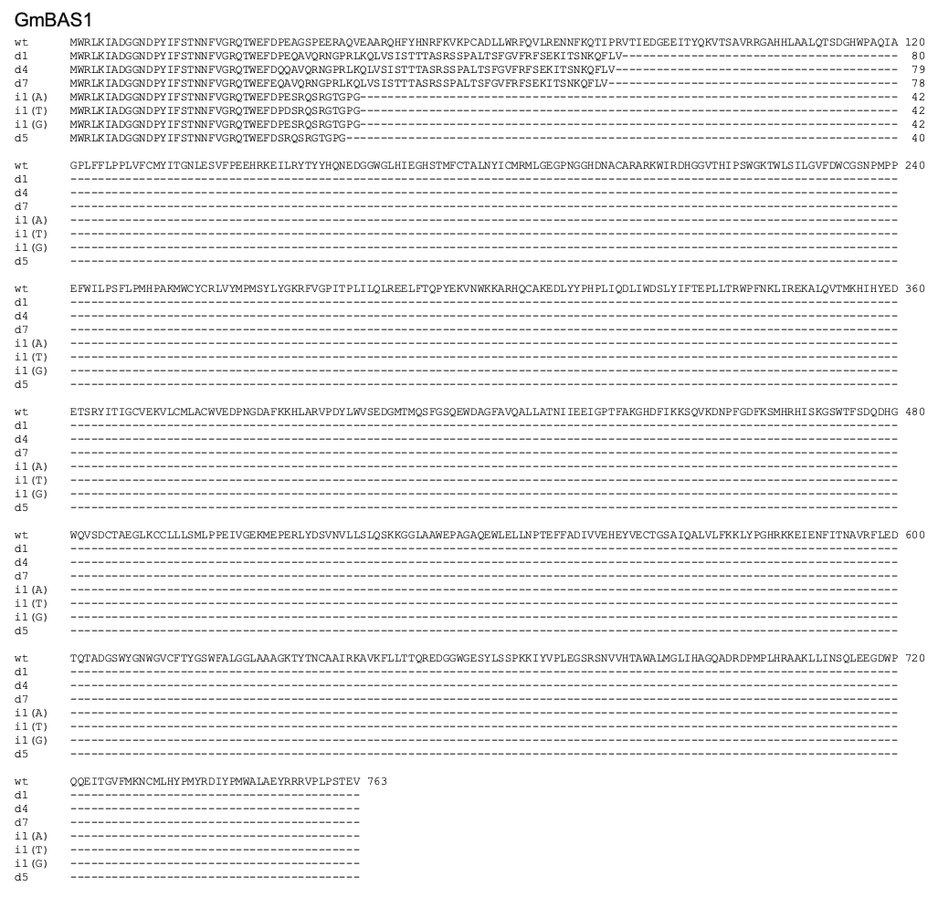

b
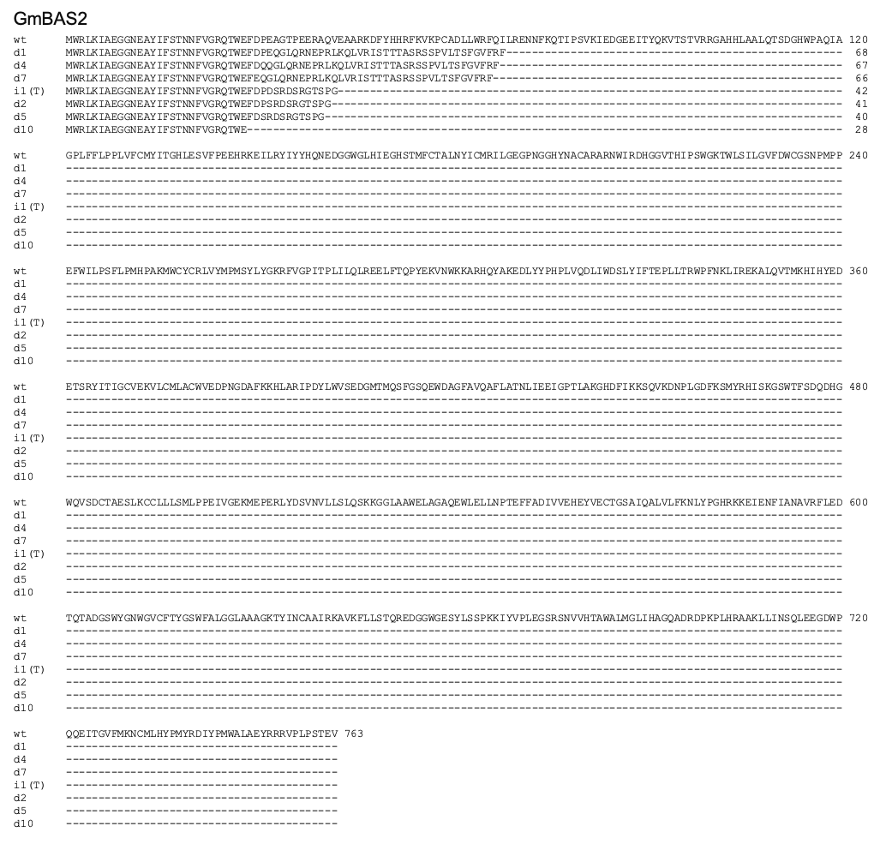
Supplementary Fig. S1 Predicted amino acid sequences of mutant GmBAS proteins in mutant and control plants.
‘WT’ indicates the amino acid sequences of GmBAS1 and GmBAS2 genes in the control plant. Letters and numbers on the left side of the alignment indicate mutation types, e.g., d1 (a single-nucleotide deletion) and i1 (a single-nucleotide insertion). All frameshift mutations detected in this study result in premature stop codon.

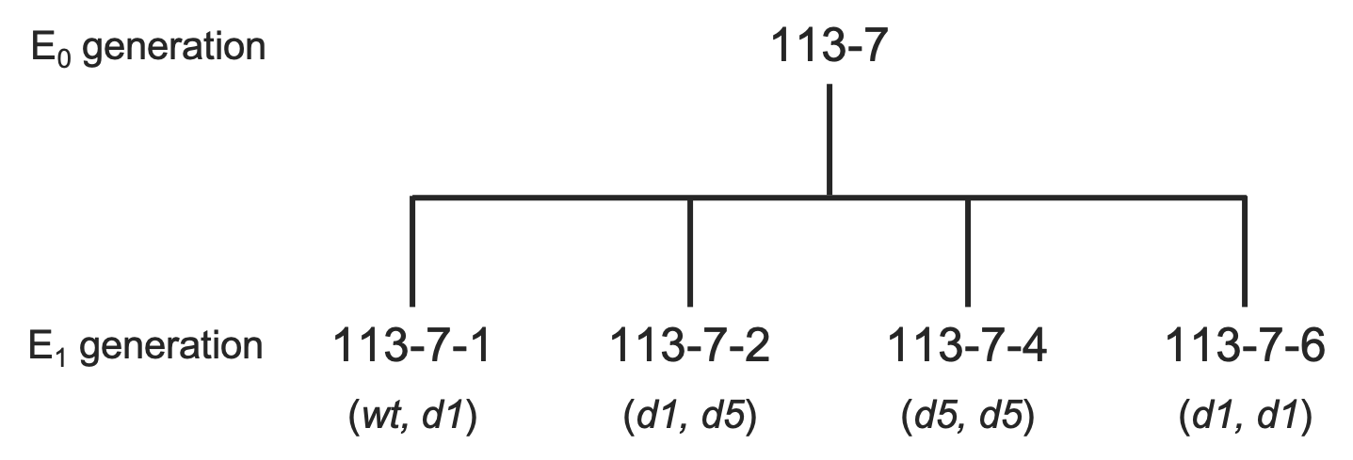
Supplementary Fig. S2 Mutant alleles in the GmBAS1 loci in the E1 generation derived from 113-7.
Italic letters denote mutation types: e. g., d1 (a single-nucleotide deletion).

a
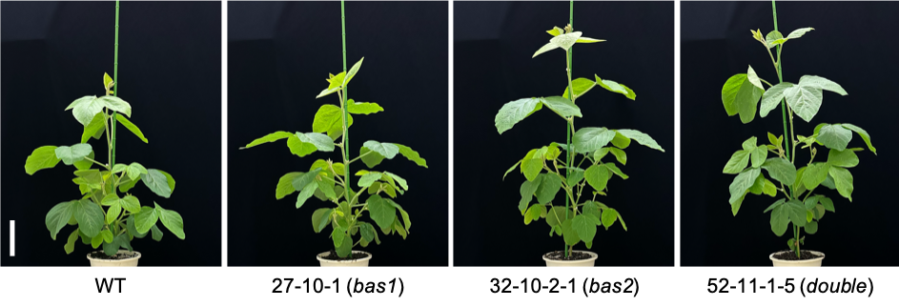
b
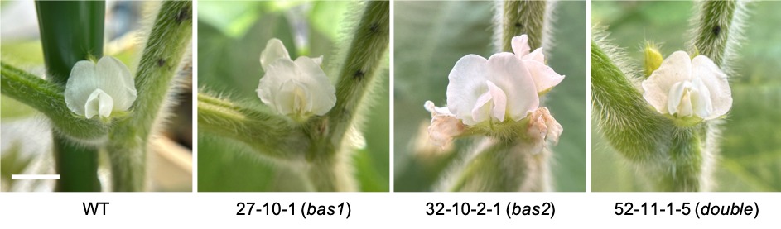
c
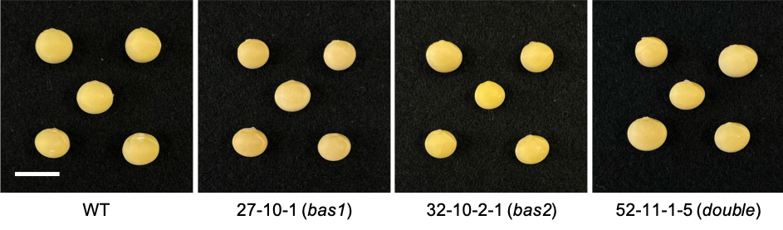
Supplementary Fig. S3. Morphological characteristics of representative mutant and control plants.
a Whole plants (1 month after sowing). Scale bar = 10 cm
b Flowers. Scale bar = 0.5 cm
c Mature seeds. Scale bar = 1 cm
‘WT’ indicates the image of a control plant. Numbers bottom of each panel indicate mutant line number.

