Supporting information

Design of a tetravalent RGD peptide capable of simultaneous binding with multiple integrin αvβ3 for targeted radionuclide therapy

Authors:
Yuki Mizuno^{1,2*}, Thanakrit Suebboonprathueng³, Satoru Onoe⁴, Hiromichi Akizawa⁴, Ken-ichi Nishijima⁵, Kazuhiro Takahashi⁵, Yuji Kuge^{1,2}
¹ Central Institute of Isotope Science, Hokkaido University, Sapporo 060-0815, Japan
² Global Center for Biomedical Science and Engineering, Hokkaido University, Sapporo 060-8638, Japan
³ Graduate School of Biomedical Science and Engineering, Hokkaido University, Sapporo 060-8638, Japan
⁴ Laboratory of Physical Chemistry, Showa Pharmaceutical University, Machida 194-8543, Japan
⁵ Advanced Clinical Research Center, Fukushima Medical University, Fukushima 960-1295, Japan
*Corresponding Author:
Yuki Mizuno: mizuno@ric.hokudai.ac.jp
Table of Contents
Abbreviations S2
HPLC methods S3-S4
HPLC chromatograms S5-S7
Western blotting and cell uptake results S8
ESI-MS spectrums S9-S10
¹H NMR spectrums S11-S13
Biodistribution S14-S20
Supplementary methods S21-S23
References S24
Abbreviations
BSA, bovine serum albumin; D-PBS, Dulbecco's phosphate buffered saline; EtOH, ethanol; HRP, horseradish peroxidase; MeOH, methanol; MeCN, acetonitrile; SDS-PAGE, sodium dodecyl sulfate polyacrylamide gel electrophoresis; PVDF, polyvinylidene fluoride; TBST, tris buffered saline with tween 20; Tris, tris(hydroxymethyl)aminomethane; TFA, trifluoroacetic acid.

HPLC methods. High-performance liquid chromatography (HPLC) analyses were performed on Shimazu system (LC-20AD, Shimadzu Co., Japan) equipped with a UV/Vis and radio-detector. UV absorbance was measured at 254 and 220 nm. Radioactivity was monitored using an in-line NaI(Tl) radio-detector (Gabi star®, Elysia Raytest Co., Germany).
Analytical HPLC was performed with a Cosmosil 5C18-AR-II (5 μm, 4.6 × 150 mm, NACALAI TESQUE, INC., Japan) at a flow rate of 1 mL/min. The details of analytical HPLC systems are summarized in Table S1. Preparative HPLC was performed with a Cosmosil 5C18-AR-II (5 μm, 20 × 150 mm, NACALAI TESQUE, INC., Japan) connected with a Cosmosil 5C18-AR-II guard column (5 μm, 20 × 20 mm) at a flow rate of 5 mL/min. The details of preparative HPLC systems are summarized in Table S2.

Table S1. System for analytical HPLC
No. | Solvent A | Solvent B | Gradient
1 | 0.1%TFA/H₂O | 0.1%TFA/MeOH | B: 30-30-100%  (0-5-10 min)
2 | 0.1%TFA/H₂O | 0.1%TFA/MeOH | B: 45-55%  (0-20 min)
3 | 0.1%TFA/H₂O | 0.1%TFA/MeOH | B: 40-70%  (0-20 min)
4 | 0.1%TFA/H₂O | 0.1%TFA/MeCN | B: 40-90%  (0-15 min)

Table S2. Systems for preparative HPLC
No. | Solvent A | Solvent B | Gradient
5 | 0.1%TFA/H₂O | 0.1%TFA/MeOH | B: 50-100%  (0-20 min)
6 | 0.1%TFA/H₂O | 0.1%TFA/MeOH | B: 70-100%  (0-30 min)
7 | 0.1%TFA/H₂O | 0.1%TFA/MeOH | B: 60-90%  (0-20 min)
8 | 0.1%TFA/H₂O | 0.1%TFA/MeOH | B: 75-90%  (0-30 min)
9 | 0.1%TFA/H₂O | 0.1%TFA/MeOH | B: 30-70%  (0-30 min)
10 | 0.1%TFA/H₂O | 0.1%TFA/MeOH | B: 50-100%  (0-30 min)
11 | 0.1%TFA/H₂O | 0.1%TFA/MeOH | B: 70-90%  (0-30 min)
12 | 0.1%TFA/H₂O | 0.1%TFA/MeOH | B: 80-100%  (0-30 min)
13 | 0.1%TFA/H₂O | 0.1%TFA/MeOH | B: 50-80%  (0-30 min)
14 | 0.1%TFA/H₂O | 0.1%TFA/MeCN | B: 50-100%  (0-25 min)
15 | 0.1%TFA/H₂O | 0.1%TFA/MeCN | B: 40-100%  (0-30 min)

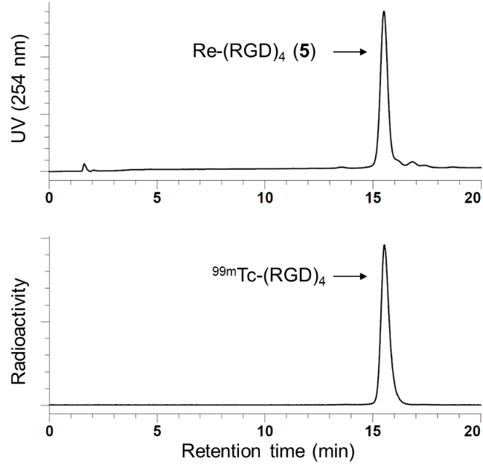
Figure S1. An HPLC chromatogram of the mixture of Re-(RGD)₄ (5) and purified ^{99m}Tc-(RGD)₄ (system 2). The radiochemical purity of ^{99m}Tc-(RGD)₄ was higher than 95%.

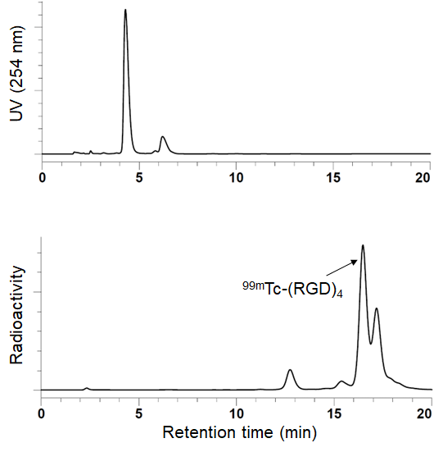
Figure S2. An HPLC chromatogram of a crude reaction solution of ^{99m}Tc-(RGD)₄ (system 2).

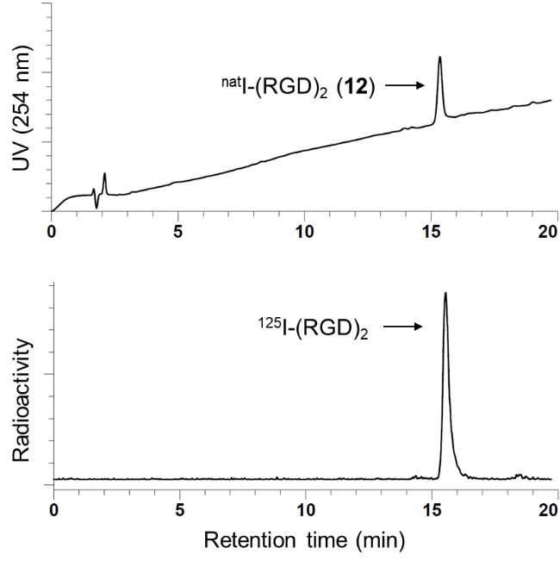
Figure S3. An HPLC chromatogram of the mixture of ^{nat}I-(RGD)₂ (12) and purified ¹²⁵I-(RGD)₂ (system 3). The radiochemical purity of ¹²⁵I-(RGD)₂ was higher than 95%.

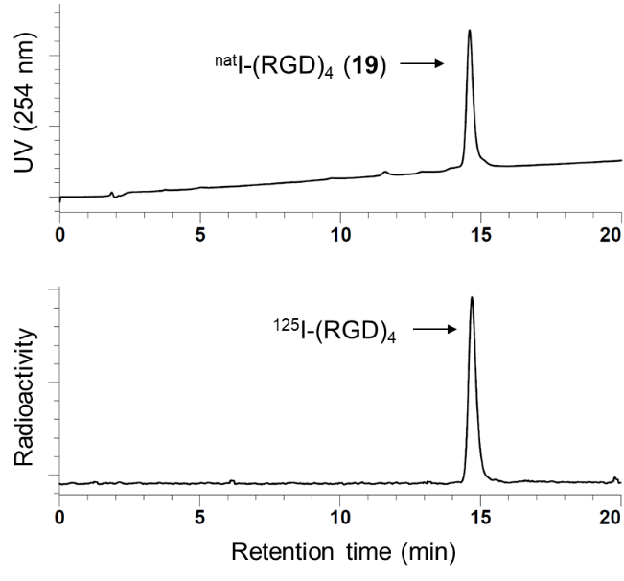
Figure S4. An HPLC chromatogram of the mixture of ^{nat}I-(RGD)₄ (19) and purified ¹²⁵I-(RGD)₄ (system 3). The radiochemical purity of ¹²⁵I-(RGD)₄ was higher than 95%.

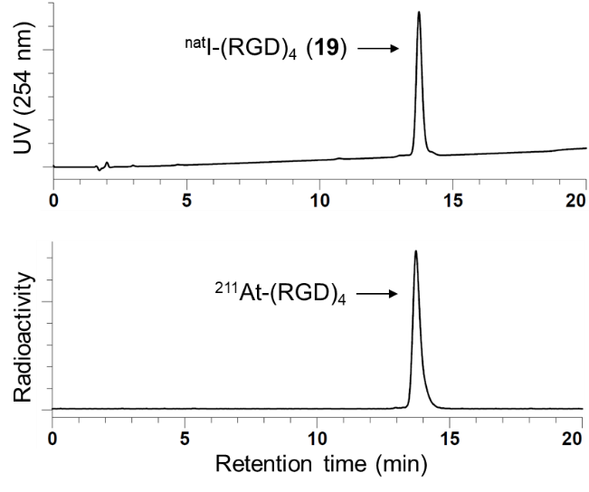
Figure S5. An HPLC chromatogram of the mixture of ^{nat}I-(RGD)₄ (19) and purified ²¹¹At-(RGD)₄ (system 3). The radiochemical purity of ²¹¹At-(RGD)₄ was higher than 95%.

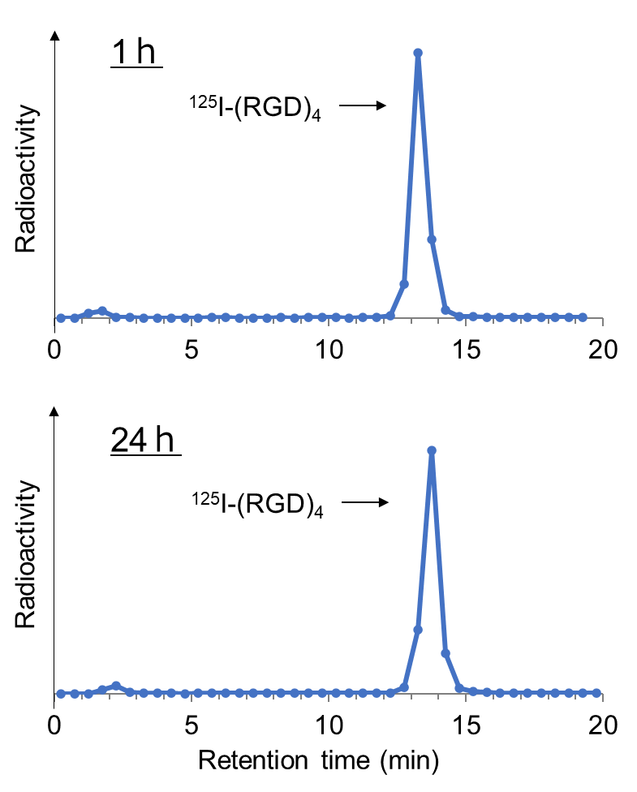
Figure S6. HPLC analyses of ¹²⁵I-(RGD)₄ after the incubation in mouse plasma for 1 h and 24 h (system 3). No degradation of ¹²⁵I-(RGD)₄ was observed even after 24 h incubation.

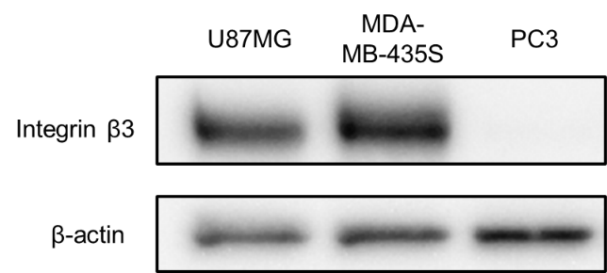
Figure S7. Representative western blot images of integrin β3 in U87MG, MDA-MB-435S, and PC3. The expression level of β-actin is shown as an internal control. PC3 was evaluated as a negative control.

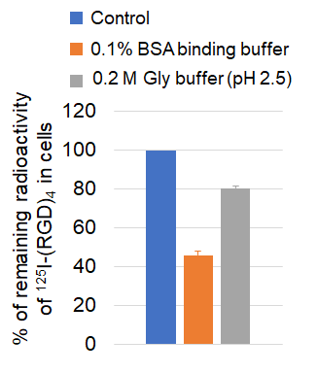
Figure S8. Percentages of remaining radioactivity of ¹²⁵I-(RGD)₄ in U87MG cells after two different washing methods. U87MG cells were incubated with ¹²⁵I-(RGD)₄ at 37℃ for 2 h. The cells were then washed with 0.1%BSA binding buffer at 37℃ for 10 min or with 0.2 M Gly buffer (pH 2.5) at room temperature for 10 min. The % of remaining radioactivity was determined by dividing (the remaining radioactivity in the cells after washing) by (the radioactivity before washing) × 100. The results are expressed as mean ± SD (n = 3).
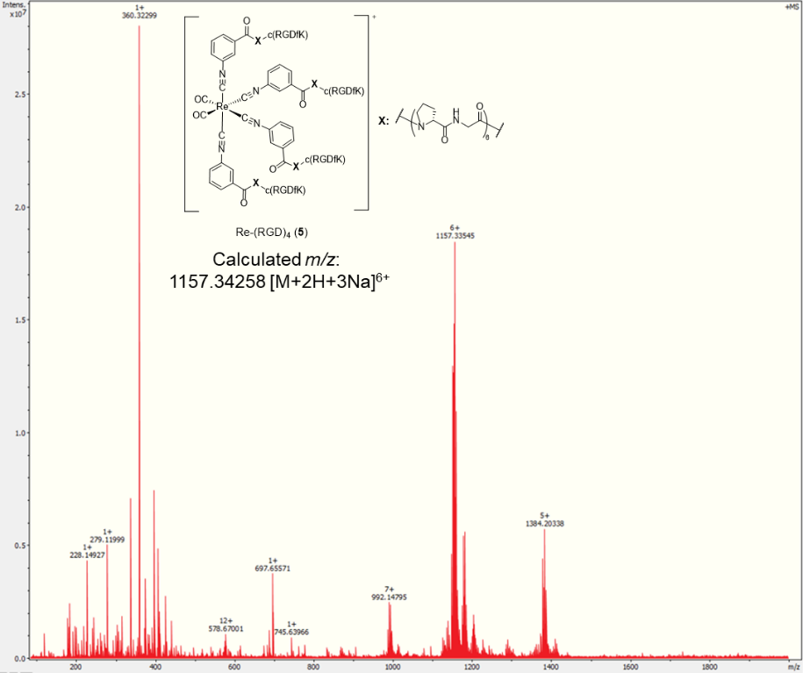
Figure S9. ESI-MS spectrum of Re-(RGD)₄ (5).

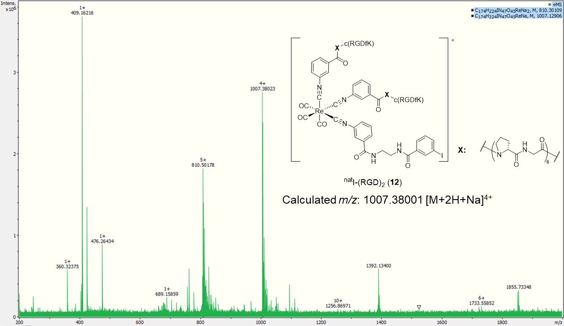
Figure S10. ESI-MS spectrum of ^{nat}I-(RGD)₂ (12).
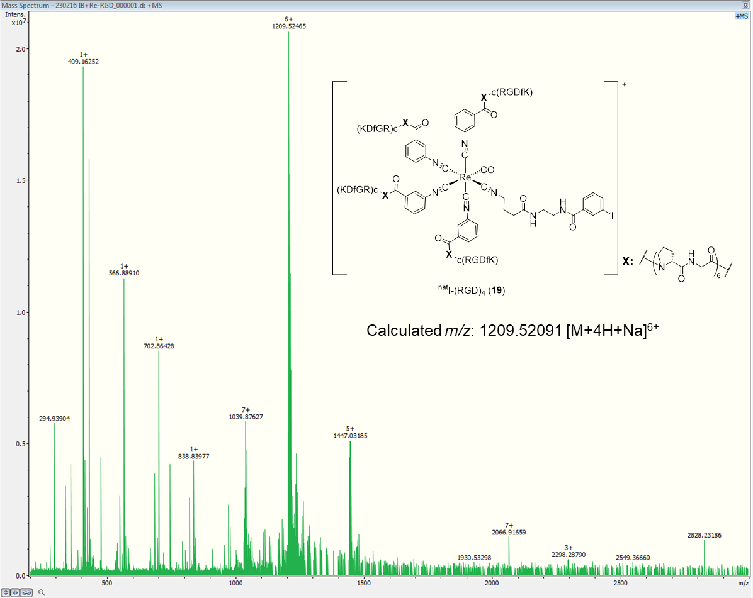
Figure S11. ESI-MS spectrum of ^{nat}I-(RGD)₄ (19).

CDCl₃
TMS
H₂O
Figure S12. ¹H-NMR spectrum (CDCl₃, 400 MHz) of [Re^{I}(CN-OMe)₄(CO)Br] (14). The spectrum indicates the mixture of 14a and 14b.

CDCl₃
TMS
H₂O
Figure S13. ¹H-NMR spectrum (CDCl₃, 400 MHz) of cis-[Re^{I}(CN-OMe)₄(CO)(CN-GABA-Et-NH-Boc)]CF₃CO₂ (15a).

CHCl₃
H₂O
TMS
Figure S14. ¹H-NMR spectrum (CDCl₃, 400 MHz) of trans-[Re^{I}(CN-OMe)₄(CO)(CN-GABA-Et-NH-Boc)]CF₃CO₂ (15b).

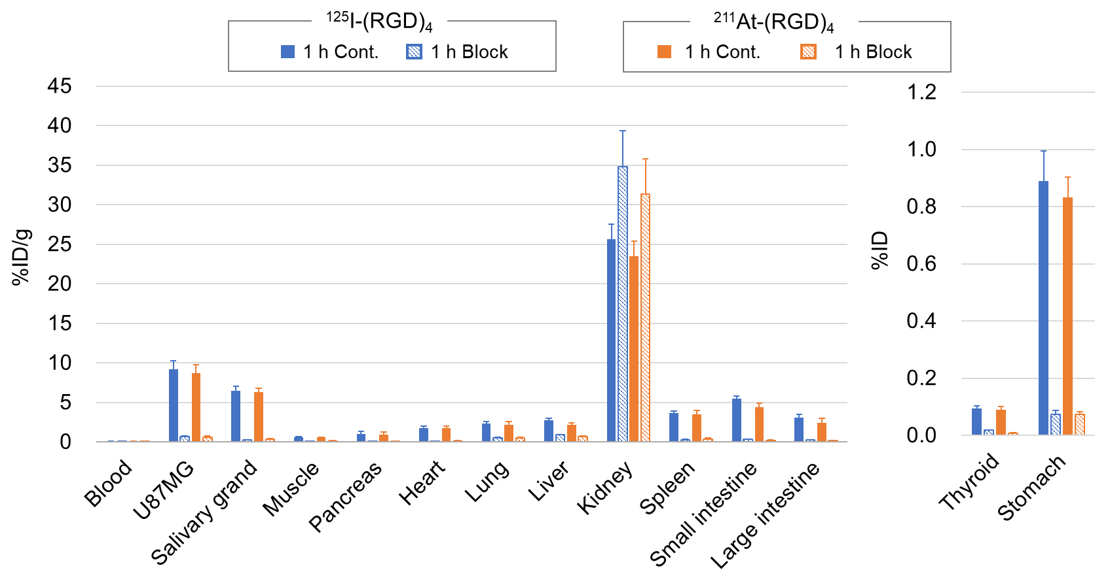
Figure S15. The biodistribution of ¹²⁵I-(RGD)₄ and ²¹¹At-(RGD)₄ in nude mice bearing U87MG tumors at 1 h post-injection with (Block) or without (Cont.) co-injection of 500 nmol of c(RGDfK). The results are expressed as %ID/g or %ID and mean ± SD (n = 3 or 4).
Table S3. Biodistribution of ^{99m}Tc-(RGD)₆ (co-injected with ¹²⁵I-(RGD)₂) in tumor-bearing miceª
Tissue | 1 h | 4 h | 24 h
U87MG | 9.13 ± 0.96 | 8.72 ± 0.48 | 5.88 ± 0.98
MDA-MB-435S | 6.90 ± 0.85 | 5.84 ± 1.85 | 5.68 ± 0.82
Blood | 0.17 ± 0.02 | 0.05 ± 0.02 | 0.02 ± 0.01
Muscle | 0.61 ± 0.09 | 0.57 ± 0.02 | 0.44 ± 0.06
Liver | 4.12 ± 0.32 | 4.14 ± 0.39 | 4.45 ± 0.77
Spleen | 5.68 ± 0.91 | 5.79 ± 0.67 | 5.24 ± 1.07
Kidney | 29.20 ± 2.81 | 27.09 ± 2.88 | 16.40 ± 3.50
Pancreas | 1.35 ± 0.09 | 1.46 ± 0.10 | 1.13 ± 0.11
Heart | 1.46 ± 0.14 | 1.33 ± 0.21 | 1.09 ± 0.22
Lung | 2.23 ± 0.23 | 1.67 ± 0.23 | 1.08 ± 0.22
Stomach^{b} | 1.17 ± 0.08 | 1.13 ± 0.10 | 1.05 ± 0.18
Intestine | 4.84 ± 0.65 | 5.38 ± 0.75 | 4.74 ± 0.38
U87/Blood^{c} | 54.68 ± 4.73 | 174.58 ± 45.68 | 408.62 ± 155.51
MDA-MB-435S/Blood^{c} | 41.34 ± 4.54 | 111.25 ± 26.81 | 394.60 ± 144.73

ªThe results were expressed as percent injected dose per gram (%ID/g) ± SD (n = 4 or 5).
^{b}The results were expressed as percent injected dose (%ID) ± SD (n = 4 or 5)
^{c}The results are expressed as a ratio.

Table S4. Biodistribution of ^{99m}Tc-(RGD)₄ (co-injected with ¹²⁵I-(RGD)₄) in tumor-bearing miceª
Tissue | 1 h | Block (1 h) | 4 h | 24 h
U87MG | 9.61 ± 1.69 | 0.68 ± 0.06 | 10.43 ± 1.82 | 6.86 ± 1.38
MDA-MB-435S | 6.34 ± 1.17 | 0.55 ± 0.55 | 5.74 ± 1.55 | 4.59 ± 1.20
Blood | 0.12 ± 0.01 | 0.16 ± 0.01 | 0.02 ± 0.002 | 0.01 ± 0.00
Muscle | 0.61 ± 0.11 | 0.07 ± 0.002 | 0.52 ± 0.04 | 0.37 ± 0.06
Liver | 2.95 ± 0.42 | 0.30 ± 0.02 | 3.13 ± 0.70 | 2.51 ± 0.27
Spleen | 3.97 ± 0.43 | 0.27 ± 0.004 | 4.16 ± 0.24 | 3.59 ± 0.49
Kidney | 15.20 ± 0.98 | 17.77 ± 1.08 | 13.60 ± 2.18 | 8.60 ± 0.41
Pancreas | 0.98 ± 0.12 | 0.11 ± 0.01 | 0.96 ± 0.11 | 0.76 ± 0.10
Heart | 1.32 ± 0.19 | 0.14 ± 0.01 | 1.20 ± 0.07 | 0.86 ± 0.11
Lung | 1.94 ± 0.44 | 0.52 ± 0.06 | 1.12 ± 0.27 | 0.92 ± 0.25
Stomach^{b} | 1.17 ± 0.51 | 0.05 ± 0.01 | 0.85 ± 0.13 | 0.80 ± 0.11
Intestine | 4.12 ± 0.44 | 0.14 ± 0.02 | 4.03 ± 0.26 | 2.93 ± 0.43
U87/Blood^{c} | 77.38 ± 8.77 | 4.19 ± 0.11 | 443.97 ± 69.90 | 615.84 ± 194.33
MDA-MB-435S/Blood^{c} | 50.91 ± 5.43 | 3.43 ± 0.12 | 408.97 ± 85.65 | 395.68 ± 83.23

ªThe results were expressed as percent injected dose per gram (%ID/g) ± SD (n = 3, 4, 5, or 6).
^{b}The results were expressed as percent injected dose (%ID) ± SD (n = 3, 4, 5, or 6)
^{c}The results are expressed as a ratio.

Table S5. Biodistribution of ¹²⁵I-(RGD)₄ (co-injected with ^{99m}Tc-(RGD)₄) in tumor-bearing miceª
Tissue | 1 h | Block (1 h) | 4 h | 24 h
U87MG | 9.33 ± 1.69 | 0.83 ± 0.05 | 10.74 ± 1.78 | 7.38 ± 1.53
MDA-MB-435S | 6.16 ± 1.28 | 0.71 ± 0.05 | 5.93 ± 1.72 | 5.06 ± 1.03
Blood | 0.15 ± 0.01 | 0.22 ± 0.01 | 0.05 ± 0.01 | 0.02 ± 0.00
Muscle | 0.62 ± 0.10 | 0.09 ± 0.01 | 0.54 ± 0.06 | 0.45 ± 0.05
Liver | 3.31 ± 0.37 | 1.20 ± 0.09 | 3.74 ± 0.72 | 3.12 ± 0.33
Spleen | 4.17 ± 0.40 | 0.46 ± 0.02 | 4.50 ± 0.28 | 4.14 ± 0.50
Kidney | 26.86 ± 1.51 | 40.82 ± 1.95 | 26.58 ± 4.19 | 16.75 ± 0.81
Pancreas | 1.02 ± 0.09 | 0.15 ± 0.01 | 1.10 ± 0.16 | 0.92 ± 0.13
Heart | 1.40 ± 0.23 | 0.19 ± 0.03 | 1.37 ± 0.07 | 1.05 ± 0.15
Lung | 2.12 ± 0.47 | 0.96 ± 0.32 | 1.31 ± 0.31 | 1.12 ± 0.27
Stomach^{b} | 1.30 ± 0.52 | 0.19 ± 0.03 | 0.96 ± 0.17 | 0.88 ± 0.13
Intestine | 4.05 ± 0.53 | 0.31 ± 0.02 | 4.13 ± 0.27 | 3.05 ± 0.43
U87/Blood^{c} | 61.66 ± 9.97 | 3.85 ± 0.32 | 220.72 ± 28.78 | 425.74 ± 71.55
MDA-MB-435S/Blood^{c} | 40.61 ± 7.10 | 3.27 ± 0.16 | 120.84 ± 25.68 | 291.55 ± 48.07

ªThe results were expressed as percent injected dose per gram (%ID/g) ± SD (n = 3, 4, 5, or 6).
^{b}The results were expressed as percent injected dose (%ID) ± SD (n = 3, 4, 5, or 6).
^{c}The results are expressed as a ratio.

Table S6. Biodistribution of ¹²⁵I-(RGD)₂ (co-injected with ^{99m}Tc-(RGD)₆) in tumor-bearing miceª
Tissue | 1 h | 4 h | 24 h
U87MG | 9.07 ± 1.42 | 7.36 ± 0.61 | 4.56 ± 1.16
MDA-MB-435S | 6.48 ± 0.43 | 6.03 ± 1.89 | 4.62 ± 0.60
Blood | 0.39 ± 0.01 | 0.11 ± 0.01 | 0.05 ± 0.01
Muscle | 0.53 ± 0.06 | 0.44 ± 0.04 | 0.31 ± 0.04
Liver | 3.08 ± 0.18 | 3.10 ± 0.32 | 2.71 ± 0.56
Spleen | 3.24 ± 0.17 | 3.32 ± 0.49 | 2.62 ± 0.52
Kidney | 9.95 ± 0.36 | 9.30 ± 0.69 | 5.72 ± 1.04
Pancreas | 0.57 ± 0.08 | 0.55 ± 0.09 | 0.42 ± 0.05
Heart | 0.97 ± 0.10 | 0.91 ± 0.10 | 0.69 ± 0.12
Lung | 2.71 ± 0.44 | 1.72 ± 0.19 | 0.99 ± 0.15
Stomach^{b} | 0.63 ± 0.06 | 0.56 ± 0.09 | 0.48 ± 0.11
Intestine | 2.69 ± 0.28 | 2.85 ± 0.23 | 1.99 ± 0.14
U87/Blood^{c} | 23.47 ± 3.60 | 69.66 ± 8.67 | 95.61 ± 16.59
MDA-MB-435S/Blood^{c} | 16.76 ± 0.91 | 57.56 ± 21.26 | 97.98 ± 5.06

ªThe results were expressed as percent injected dose per gram (%ID/g) ± SD (n = 4 or 5).
^{b}The results were expressed as percent injected dose (%ID) ± SD (n = 4 or 5)
^{c}The results are expressed as a ratio.

Table S7. Biodistribution of ¹²⁵I-(RGD)₄ (co-injected with ²¹¹At-(RGD)₄) in tumor-bearing miceª
Tissue | 5 min | 1 h | Block (1 h) | 4 h | 24 h
Blood | 2.81 ± 1.01 | 0.10 ± 0.00 | 0.10 ± 0.01 | 0.02 ± 0.00 | 0.01 ± 0.00
U87MG | 7.14 ± 1.39 | 9.22 ± 1.05 | 0.69 ± 0.06 | 9.13 ± 2.33 | 7.03 ± 0.61
Thyroid^{b} | 0.12 ± 0.02 | 0.09 ± 0.01 | 0.02 ± 0.00 | 0.09 ± 0.01 | 0.09 ± 0.01
Salivary grand | 10.44 ± 0.79 | 6.49 ± 0.55 | 0.27 ± 0.02 | 6.42 ± 1.18 | 5.31 ± 0.42
Muscle | 0.95 ± 0.16 | 0.59 ± 0.06 | 0.04 ± 0.01 | 0.58 ± 0.08 | 0.46 ± 0.06
Pancreas | 2.73 ± 0.32 | 1.01 ± 0.34 | 0.10 ± 0.01 | 1.34 ± 0.18 | 1.08 ± 0.11
Heart | 3.44 ± 0.38 | 1.73 ± 0.32 | 0.12 ± 0.01 | 1.92 ± 0.30 | 1.28 ± 0.04
Lung | 4.12 ± 0.74 | 2.31 ± 0.31 | 0.51 ± 0.10 | 2.73 ± 0.30 | 1.74 ± 0.07
Liver | 5.91 ± 0.91 | 2.73 ± 0.27 | 0.91 ± 0.04 | 3.07 ± 0.25 | 2.90 ± 0.21
Kidney | 37.65 ± 7.46 | 25.66 ± 1.88 | 34.84 ± 4.50 | 25.21 ± 1.22 | 14.99 ± 1.37
Spleen | 5.35 ± 0.52 | 3.64 ± 0.27 | 0.29 ± 0.06 | 5.20 ± 0.52 | 4.51 ± 1.13
Stomach^{b} | 1.28 ± 0.14 | 0.89 ± 0.11 | 0.07 ± 0.01 | 0.78 ± 0.03 | 0.71 ± 0.04
Small intestine | 6.63 ± 0.55 | 5.45 ± 0.38 | 0.32 ± 0.05 | 3.86 ± 0.67 | 3.97 ± 0.48
Large intestine | 3.55 ± 0.25 | 3.06 ± 0.47 | 0.24 ± 0.01 | 2.05 ± 0.25 | 1.53 ± 0.21
U87/Blood^{c} | 2.78 ± 1.01 | 88.00 ± 10.84 | 7.27 ± 1.52 | 465.50 ± 125.07 | 550.64 ±109.51
ªThe results were expressed as percent injected dose per gram (%ID/g) ± SD (n = 3 or 4).
^{b}The results were expressed as percent injected dose (%ID) ± SD (n = 3 or 4)
^{c}The results are expressed as a ratio.

Table S8. Biodistribution of ²¹¹At-(RGD)₄ (co-injected with ¹²⁵I-(RGD)₄) in tumor-bearing miceª
Tissue | 5 min | 1 h | Block (1 h) | 4 h | 24 h
Blood | 2.29 ± 0.79 | 0.09 ± 0.02 | 0.07 ± 0.01 | 0.02 ± 0.01 | 0.02 ± 0.01
U87MG | 6.96 ± 1.47 | 8.67 ± 1.08 | 0.63 ± 0.09 | 8.91 ± 2.94 | 6.04 ± 0.72
Thyroid^{b} | 0.11 ± 0.03 | 0.09 ± 0.01 | 0.01 ± 0.00 | 0.07 ± 0.01 | 0.10 ± 0.05
Salivary grand | 10.08 ± 0.88 | 6.31 ± 0.49 | 0.31 ± 0.08 | 6.38 ± 1.41 | 5.60 ± 1.18
Muscle | 0.93 ± 0.21 | 0.56 ± 0.05 | 0.06 ± 0.10 | 0.60 ± 0.04 | 0.17 ± 0.18
Pancreas | 2.47 ± 0.36 | 0.95 ± 0.32 | 0.04 ± 0.04 | 1.19 ± 0.21 | 0.94 ± 0.34
Heart | 3.31 ± 0.35 | 1.73 ± 0.30 | 0.12 ± 0.05 | 1.78 ± 0.32 | 0.97 ± 0.06
Lung | 3.85 ± 0.71 | 2.16 ± 0.39 | 0.52 ± 0.10 | 2.67 ± 0.31 | 1.59 ± 0.04
Liver | 4.73 ± 0.81 | 2.20 ± 0.19 | 0.69 ± 0.03 | 2.33 ± 0.22 | 1.87 ± 0.12
Kidney | 34.56 ± 6.34 | 23.52 ± 1.87 | 31.36 ± 4.44 | 22.51 ± 1.23 | 12.50 ± 1.07
Spleen | 4.99 ± 0.61 | 3.50 ± 0.44 | 0.39 ± 0.14 | 4.84 ± 0.54 | 3.97 ± 0.88
Stomach^{b} | 1.18 ± 0.14 | 0.83 ± 0.07 | 0.07 ± 0.01 | 0.79 ± 0.03 | 0.76 ± 0.06
Small intestine | 5.45 ± 0.51 | 4.44 ± 0.42 | 0.20 ± 0.05 | 2.92 ± 0.68 | 3.16 ± 0.51
Large intestine | 2.97 ± 0.33 | 2.41 ± 0.60 | 0.15 ± 0.02 | 1.70 ± 0.27 | 1.21 ± 0.16
U87/Blood^{c} | 3.31 ± 1.20 | 94.19 ± 11.94 | 9.34 ± 3.01 | 425.65 ± 209.64 | 426.40 ± 460.76
ªThe results were expressed as percent injected dose per gram (%ID/g) ± SD (n = 3 or 4).
^{b}The results were expressed as percent injected dose (%ID) ± SD (n = 3 or 4)
^{c}The results are expressed as a ratio.

Supplementary methods.
In vitro stability of ¹²⁵I-(RGD)₄.
This experiment was performed according to the method we previously reported with slight modifications.¹ Ten microliter of ¹²⁵I-(RGD)₄ was mixed with 90 μL of mouse plasma (BALBc male mice, Japan SLC, Inc., Japan). After incubation at 37℃ for 1 and 24 h, 90 μL of EtOH was added to 45 μL of the incubation solution to precipitate the proteins. The sample was centrifuged at 15,000g for 5 min at 4℃. The supernatant was collected, and the pellet was washed with 100 μL of 66% v/v EtOH in D-PBS (-) and centrifuged again using the same condition. This washing step was repeated twice. The supernatants of both centrifugation steps were combined, and the recovery rate of radioactivity from the plasma sample was determined by the following equation, (the radioactivity of the supernatant)/(the original radioactivity of the plasma sample). The supernatant was analyzed by HPLC (system 3), and the HPLC eluent was manually collected every 0.5 min. The radioactivity of each fraction was measured using an autowell gamma counter.

In vitro binding affinity to integrin αvβ3
This experiment was performed according to the method we previously reported.² U87MG human glioma cells were grown in Dulbecco's Modified Eagle Medium (Sigma-Aldrich Japan K.K., Japan) supplemented with 10% v/v fetal bovine serum (Nippon Biosupply Center, Japan), and 1% v/v penicillin-streptomycin (10,000 unit-10 mg/mL, Sigma-Aldrich Japan K.K.) at 37 °C in humidified atmosphere containing 5% CO₂. U87MG cells were seeded at a density of 1 × 10⁵ cells per well in Type I collagen-coated plates (AGC TECHNO GLASS Co., Ltd., Japan) and allowed to attach overnight. The cells were incubated at 37 °C for 2 h with [¹²⁵I]c[RGDy(3-I)V] (5 kBq) in the binding buffer (0.1% BSA, 20 mM Tris, 150 mM NaCl, 2 mM CaCl₂, 1 mM MgCl₂, 1 mM MnCl₂, pH 7.4), in the presence of increasing concentrations of Re-(RGD)₆, Re-(RGD)₄ (5), I-(RGD)₂ (12), or I-(RGD)₄ (19). The total incubation volume was adjusted to 500 μL. After the incubation, each well was washed twice with 500 μL of the ice-cold wash buffer (20 mM Tris, 150 mM NaCl, 2 mM CaCl₂, 1 mM MgCl₂, 1 mM MnCl₂, pH 7.4). The cells were lysed by 15 min incubation with 1% SDS/0.25 M NaOH at 37 °C, and the radioactivity was determined using an autowell γ counter. The IC₅₀ values were calculated by fitting the data by nonlinear regression to a one site fit model using GraphPad Prism v. 9 (GraphPad Software, Inc., USA).

Cellular uptake and dissociation study
This experiment was performed according to the method we previously reported.² U87MG cells were seeded according to the method described elsewhere. MDA-MB-435S human melanoma cells were seeded in the same manner as U87MG. The cells were incubated with 1 kBq ¹²⁵I-(RGD)₂, 1 kBq ¹²⁵I-(RGD)₄, 10 kBq ^{99m}Tc-(RGD)₆, or 10 kBq ^{99m}Tc-(RGD)₄ in the binding buffer at 37 °C for 2 h. For the blocking experiments, the cells were incubated in the presence of 50 μM of c(RGDyV). The total incubation volume was adjusted to 500 μL. After the incubation, each well was washed twice with 500 μL of the ice-cold wash buffer. For cellular dissociation studies, the cells were successively incubated in the binding buffer at 37 °C for 1, 5, 10, and 60 min. After the incubation, each well was again washed twice with 500 μL of the ice-cold wash buffer. Finally, the cells were lysed by 15 min incubation with 1% SDS/0.25 M NaOH at 37 °C, and the radioactivity was determined using an autowell γ counter. The protein concentration of each cell lysate was determined by a micro-BCA assay (Thermo Fisher Scientific Inc., USA) using BSA as a protein standard. The results are presented as percent dose per milligram protein (%Dose/mg protein). Values were expressed as mean ± SD (n = 3). The percent of initial specific uptake was determined by the following equation: [(%Dose/mg protein at each dissociation time point) - (%Dose/mg protein at 120 min in the blocking experiment)] / [(%Dose/mg protein at 120 min) - (%Dose/mg protein at 120 min in the blocking experiment)] × 100.

Dissociation kinetics in the presence of c(RGDyV)
This experiment was performed according to the method we previously reported.² U87MG and MDA-MB-435S were seeded as described elsewhere. The cells were incubated with 1 kBq ¹²⁵I-(RGD)₂, 1 kBq ¹²⁵I-(RGD)₄, 10 kBq ^{99m}Tc-(RGD)₆, or 10 kBq ^{99m}Tc-(RGD)₄ in the binding buffer at 37 °C for 2 h. The total incubation volume was adjusted to 500 μL. After the incubation, each well was washed twice with 500 μL of the ice-cold wash buffer. The cells were successively incubated in the binding buffer containing 50 μM of c(RGDyV) at 37 °C for 1, 5, 10, and 60 min. After the incubation, each well was again washed twice with 500 μL of the ice-cold wash buffer. The residual radioactivities expressed as percent dose/mg protein were determined according to the method described in “Cellular uptake and dissociation”.

Western blot analysis
U87MG, MDA-MB-435S, and PC-3 cells were lysed in RIPA Lysis and Extraction Buffer (Thermo Fisher Scientific Inc., USA) containing a protease inhibitor cocktail (cOmpleteTM, Roche Co., Ltd., Germany). The sample solutions were centrifuged for 20 min at 16,000g at 4℃, and the pellets were discarded. The samples (2.5 μg per lane) were separated using SDS-PAGE on a 5-20% gel (e-PAGEL, ATTO Co., Ltd., Japan) and transferred to a PVDF membrane using a QBlot kit (ATTO Co., Ltd.). After the membranes were blocked with EzBlock Chemi (ATTO Co., Ltd.) for 45 min, they were incubated with anti-Integrin β3 (D7X3P) XP® Rabbit mAb (#13166, 1:1000, Cell Signaling Technology Inc., USA) at 4℃ overnight. The membranes were washed with TBST buffer and incubated with an HRP-conjugated anti-rabbit goat antibody (W4011, 1:4000; Promega Inc., USA) at room temperature for 45 min. Integrin β3 was detected using Immobilon® Western chemiluminescent HRP Substrate (Millipore Inc., USA) and a luminescent image analyzer LuminoGraph I (ATTO Co., Ltd.). β-Actin was detected by a HRP-conjugated anti-β-Actin Mouse mAb (A3854, Merck KGaA, Germany) and evaluated as a loading control.
References

(1) Mizuno, Y.; Uehara, T.; Jen, C.-W.; Akizawa, H.; Arano, Y. The synthesis of a ^{99m}Tc-labeled tetravalent targeting probe upon isonitrile coordination to ^{99m}Tc^{I} for enhanced target uptake in saturable systems. RSC Advances 2019, 9 (45), 26126-26135, 10.1039/C9RA04311J. DOI: 10.1039/C9RA04311J.
(2) Mizuno, Y.; Kimura, K.; Onoe, S.; Shukuri, M.; Kuge, Y.; Akizawa, H. Influence of Linker Molecules in Hexavalent RGD Peptides on Their Multivalent Interactions with Integrin αvβ3. J. Med. Chem. 2021, 64 (21), 16008-16019. DOI: 10.1021/acs.jmedchem.1c01396.

