Supplementary Material

Title:
Multi-Laboratory Validation of JFRL Staining for Bone Histology Across Animal Species and Bone Implant Materials

Journal name:
Microscopy and Microanalysis

Authors:
Erika Tsuji, Kanako Sumi, Natsuko Tsuzuki, Daisuke Kondoh, Masashi Tsujio, Marina Hosotani, Takashi Namba, Shoichi Wakitani, Osamu Ichii, Ko Nakanishi, Teppei Nakamura

Corresponding author:
Teppei Nakamura, D.V.M., Ph.D
Department of Biological Safety Research, Chitose Laboratory, Japan Food Research Laboratories, Bunkyo 2-3, Chitose, Hokkaido 066-0052, Japan
E-mail: nakamurate@vetmed.hokudai.ac.jp

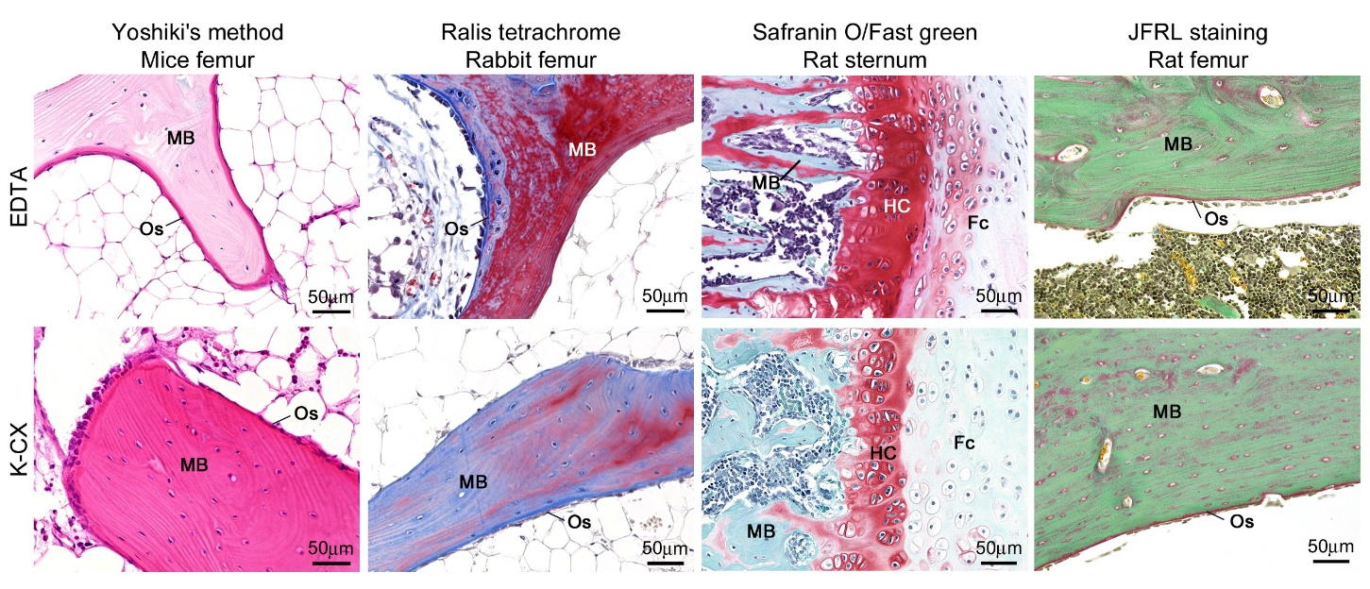
Supplemental Figure 1. Comparison of bone staining using Yoshiki's method, Ralis tetrachrome, Safranin O/Fast green staining, and JFRL staining.
Bone samples were decalcified using EDTA (chelator) or K-CX (inorganic acid). While chelator decalcification allows distinction between osteoid and mineralized bone, inorganic acid decalcification does not permit differentiation in Yoshiki's method and the Ralis tetrachrome. Although Safranin O/Fast green staining distinguished bone and hyaline cartilages, fibrocartilage showed various colors depending on the decalcification method. In contrast, JFRL staining clearly distinguishes the bone elements regardless of the decalcification method used. Fc: fibrocartilage, HC: hyaline cartilage, MB: mineralized bone, Os: osteoid.

Supplemental Table 1. Reagents used in the intra-laboratory study
Alcian blue 8GX | Weigert's iron hematoxylin | Orange G | Light green SF, yellowish | Sirius Red
RTU (40852, Muto) | RTU (40342, 40352, Muto) | RTU (40232, Muto) | RTU (40131, Muto) | RTU (33061, Muto)
 |  |  | Powder (L5382, Sigma) | Powder  (365548, Sigma)
 |  |  | Powder (124-04632, Wako) | Powder (D3273, TCI)
RTU: ready-to-use, Muto: Muto Pure Chemicals (Tokyo, Japan), Sigma: Sigma-Aldrich (MO, USA), Wako: Fujifilm Wako Pure Chemical (Osaka, Japan), TCI: Tokyo Chemical Industry (Tokyo, Japan).

Supplemental Table 2. Participating facilities and reagents used in the inter-laboratory study
Institution | Alcian blue 8GX | Weigert's iron hematoxylin | Orange G | Light green SF, yellowish | Sirius Red
Lab. A | Powder  (1A-288, Waldeck) | Laboratory preparation | RTU  (40232, Muto) | Powder  (AC229770100, Thermo) | Powder  (365548, Sigma)
Lab. B | RTU  (40852, Muto) | RTU  (40342, 40352, Muto) | RTU  (40232, Muto) | RTU  (40131, Muto) | RTU  (33061, Muto)
Lab. C | Powder  (A5268, Sigma) | RTU (HWI-A-125,  HWI-B-125, SCY) | RTU  (40232, Muto) | Powder  (124-04632, Wako) | Powder,  (D3273, TCI)
Lab. D | Powder  (A3157, Sigma) | Laboratory preparation | Powder  (150-01832, Wako) | Powder  (L5382, Sigma) | Powder  (365548, Sigma)
RTU: ready-to-use, Muto: Muto Pure Chemicals (Tokyo, Japan), Sigma: Sigma-Aldrich (MO, USA), SCY: ScyTek Laboratories (UT, USA), TCI: Tokyo Chemical Industry (Tokyo, Japan), Thermo: Thermo Fisher Scientific (MA, USA), Wako: Fujifilm Wako Pure Chemical (Osaka, Japan), Waldeck: Waldeck GmbH (Münster, Germany).
Supplemental Table 3. Updated Protocol of Join of the Five dyes Revealing coLlagenous tissue (JFRL) staining
Process | Method | Critical step and troubleshooting
Deparaffinization | - Routinely perform.
Cartilage staining  (if necessary) | - Immerse in 3% acetic acid.  - Stain with 1% Alcian blue solution (pH2.5) for 30 min at RT.  - Wash with 3% acetic acid.
Nucleus staining | - Stain with Weigert's iron hematoxylin for 10 min at RT.  - Wash with tap water. | - Differentiation can be omitted.
Red blood cell staining | - Stain with 0.75% orange G for 2 min at RT.  - Wash with 1% acetic acid.
Mineralized bone staining | - Stain with 0.5% Picro-Light Green for 3 min at RT.  - Wash with 1% acetic acid.
Osteoid staining | - Stain with 0.04% Picrosirius red solution for 5–8 min at RT.  - Wash with 1% acetic acid. | - Shorten this process in case of intense red color.  - Lengthen this process in case of intense green color.
Dehydration | - Dehydrate using 100% ethanol series for 3 to 5 min in total, followed by xylene. | - Short dehydration time leaves residual picric acid, causing yellowish specimens.  - Immerse the specimen in 70% ethanol in case of intense green color.
Coverslip | - Coverslip using a non-aqueous mounting media.
This protocol is optimized for bone sections at 4-μm thickness. Thicker and thinner sections tend to increase green and red colors, respectively. Decalcification methods do not influence the outcome of the staining characteristics, although over-decalcification fades nuclear staining. RT: room temperature. 0.75% orange G: dissolve orange G in distilled water. 0.5% picro-light green: dilute 2% light green SF solution with saturated picric acid. Solution of 0.04% picrosirius red: dilute 1% sirius red solution with saturated picric acid.

