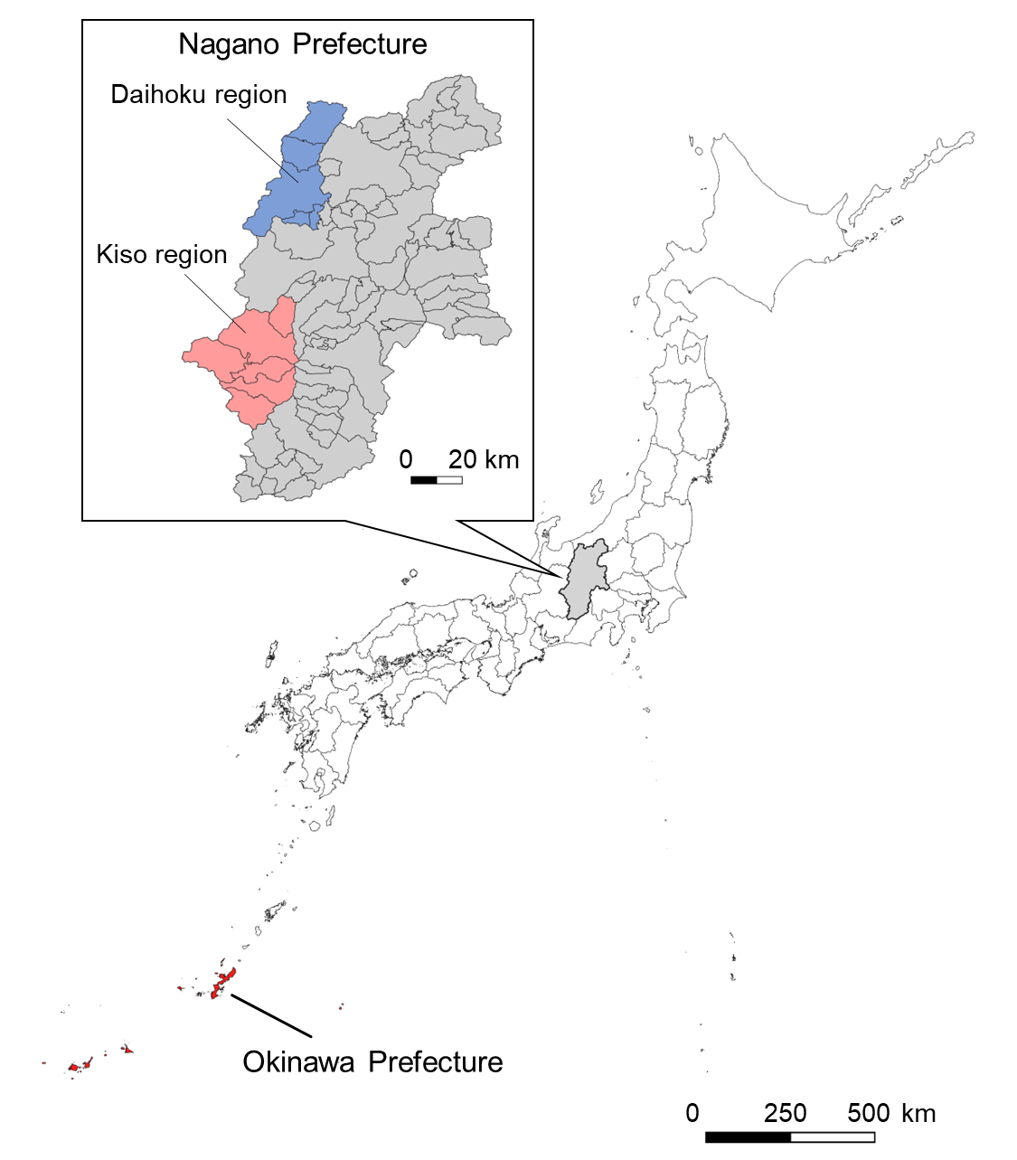
Supplementary Fig. S1. A map showing regions where Taenia solium were detected from wild boars. Nagano prefecture is highlighted in gray. The upper left inset shows regions where wild boars infected with cysticerci were found. The lower left region, filled in red, shows Okinawa Prefecture, where cysticercosis was highly endemic until the 1940s and 1950s.
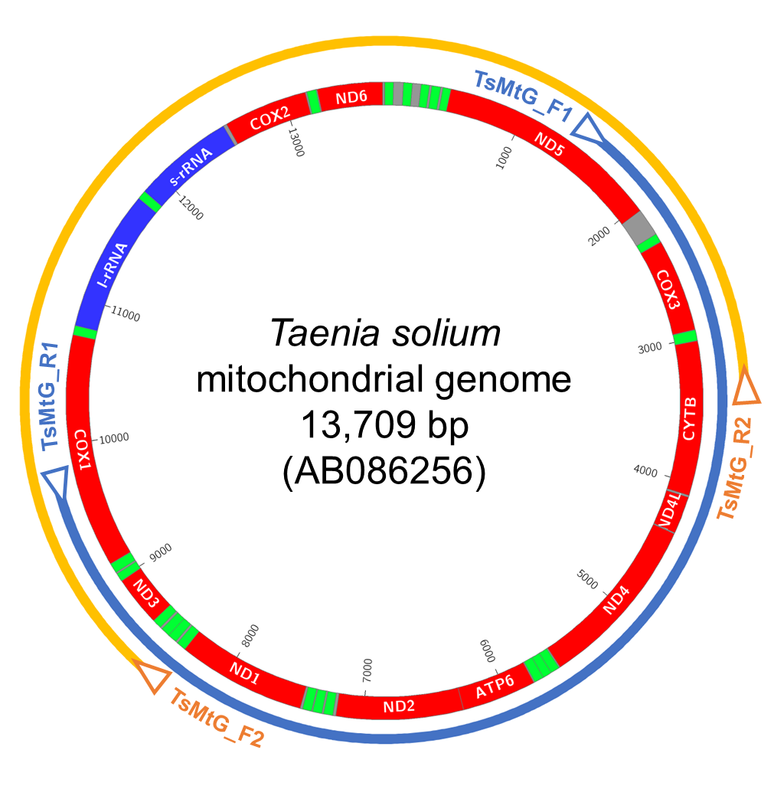
Supplementary Fig. S2. PCR strategy to amplify the mitogenome sequence of Taenia solium. Arrowheads indicate the positions of primer annealing sites. Two overlapping fragments (orange and blue) were obtained.

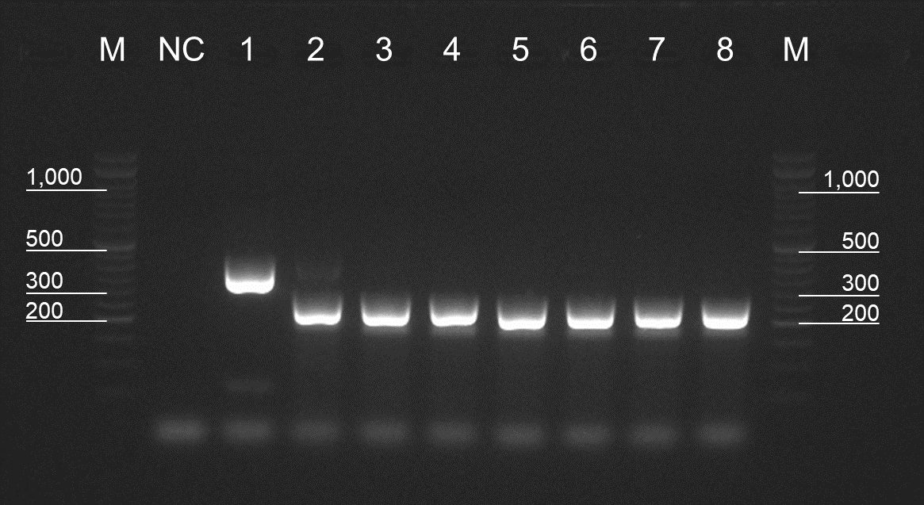
Supplementary Fig. 3. Multiplex PCR using DNA from taeniid cestodes. The PCR products were analyzed using a 2.0% agarose gel. Lane M, DNA ladder; lane NC, negative control (water); lane 1, Echinococcus multilocularis Nemuro strain; lane 2, Hydatigera taeniaeformis; lanes 3–5, cysticerci obtained in January 2023; lanes 6–8, cysticerci obtained in June 2023.

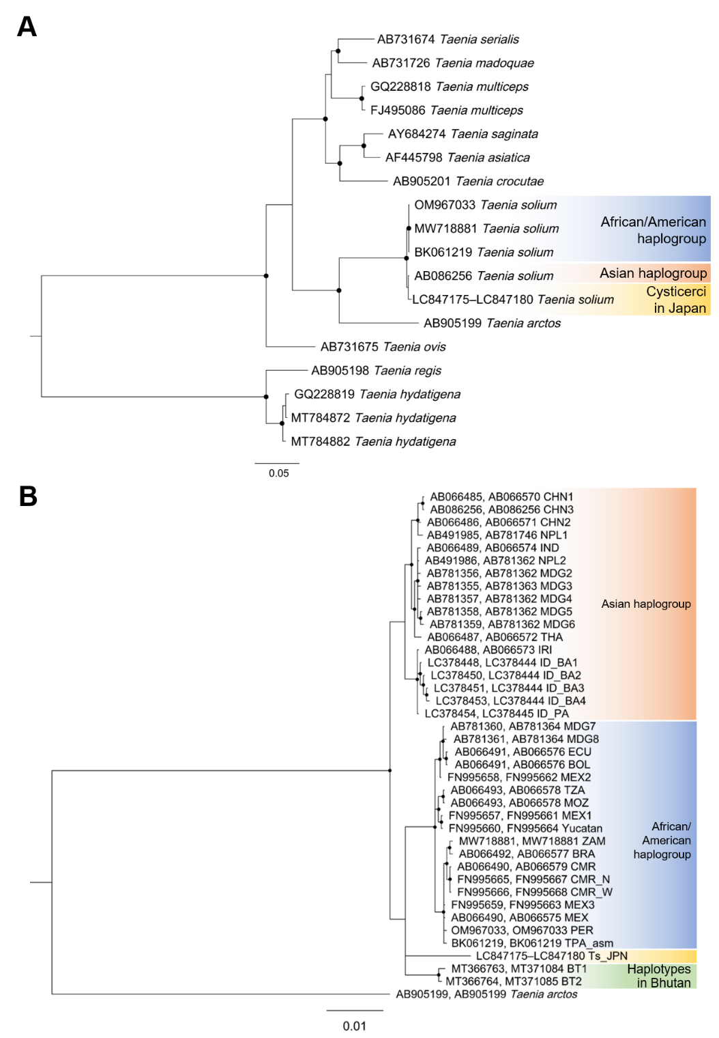
Supplementary Fig. S4. Bayesian phylogenetic trees from mitochondrial gene sequences of Taenia spp.
Phylogenetic trees were reconstructed from (A) the rrnS and rrnL genes and (B) the cox1 and cob genes. The trees were rooted with (A) Taenia regis and T. hydatigena and (B) T. arctos as outgroups. Dots on the nodes represent posterior probabilities > 0.85.

Supplementary Table S1.
Primer sequences and PCR conditions
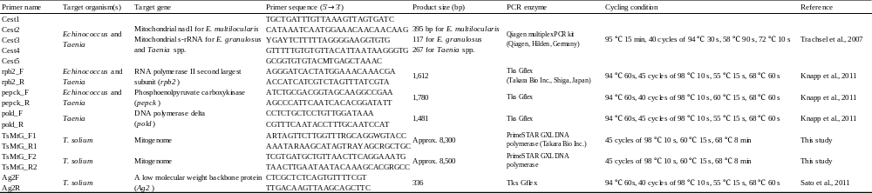

Supplementary Table S2.
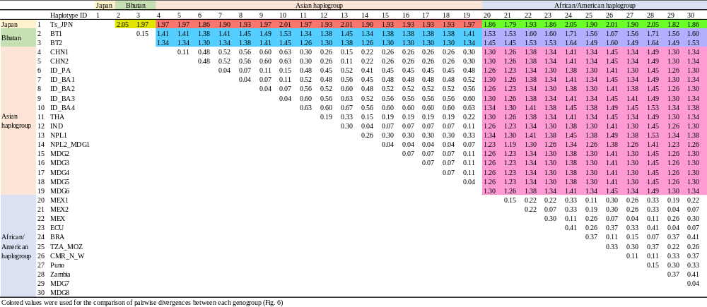
Pairwise divergences (%) between each haplotype based on mitochondrial cytochrome c oxidase subunit I (cox1) and cytochrome b (cob) sequences

