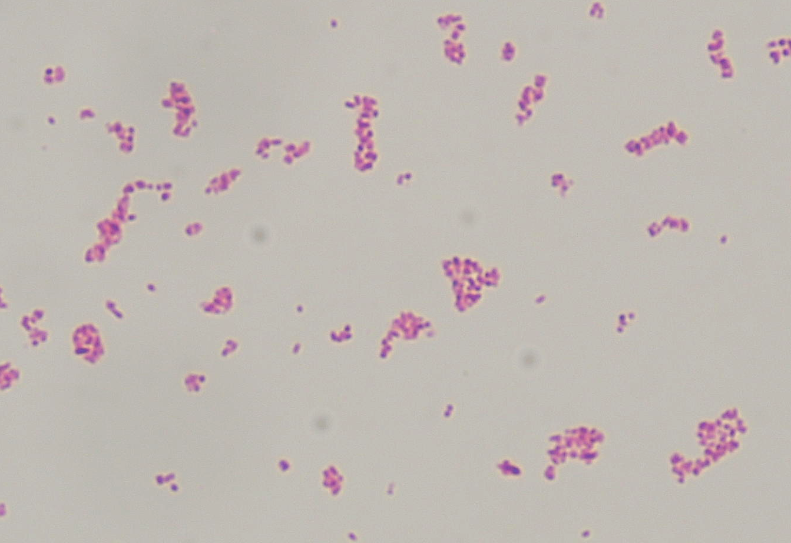

Supplementary Fig.
Cultured MAP cells after Ziehl Neelsen stain.
Clumps of MAP cells were observed after vortex mixing. Bar = 10μm.

